**Select Clause with Where clause**

1) Display details of jobs where the minimum salary is greater than 10000.

Ans-select emp.employee_id,emp.job_id,emp.salary,job.job_title from employees emp,jobs job where emp.job_id=job.job_id having salary > 10000;

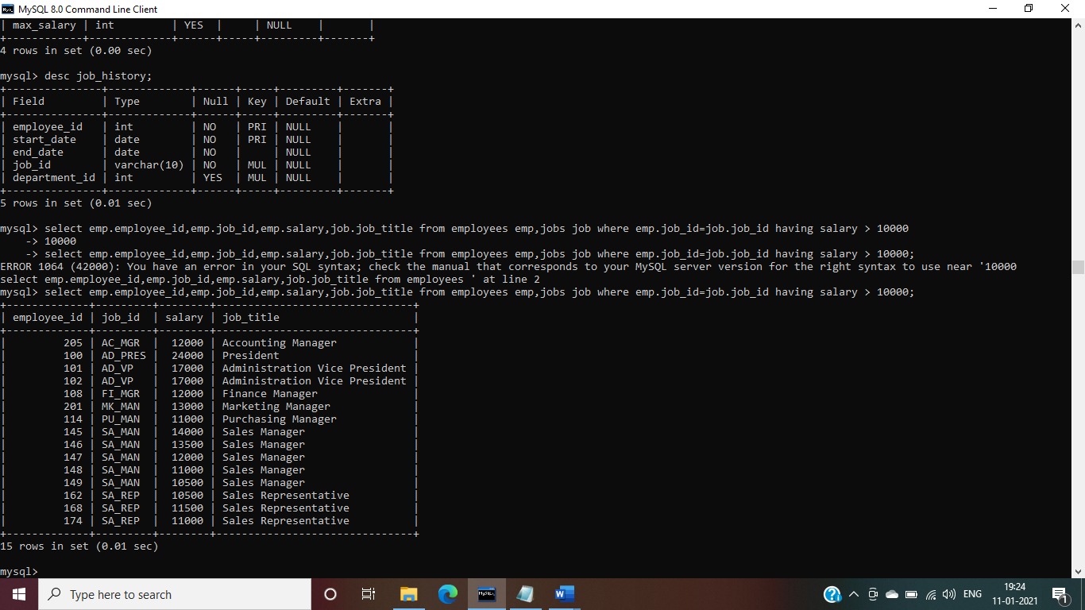

2) Display the first name and join date of the employees who joined between 2002 and 2005.

Ans- select emp.employee_id,emp.first_name,job.start_date from employees emp,job_history job where emp.employee_id=job.employee_id having start_date between '2002-01-01' and '2005-12-31';

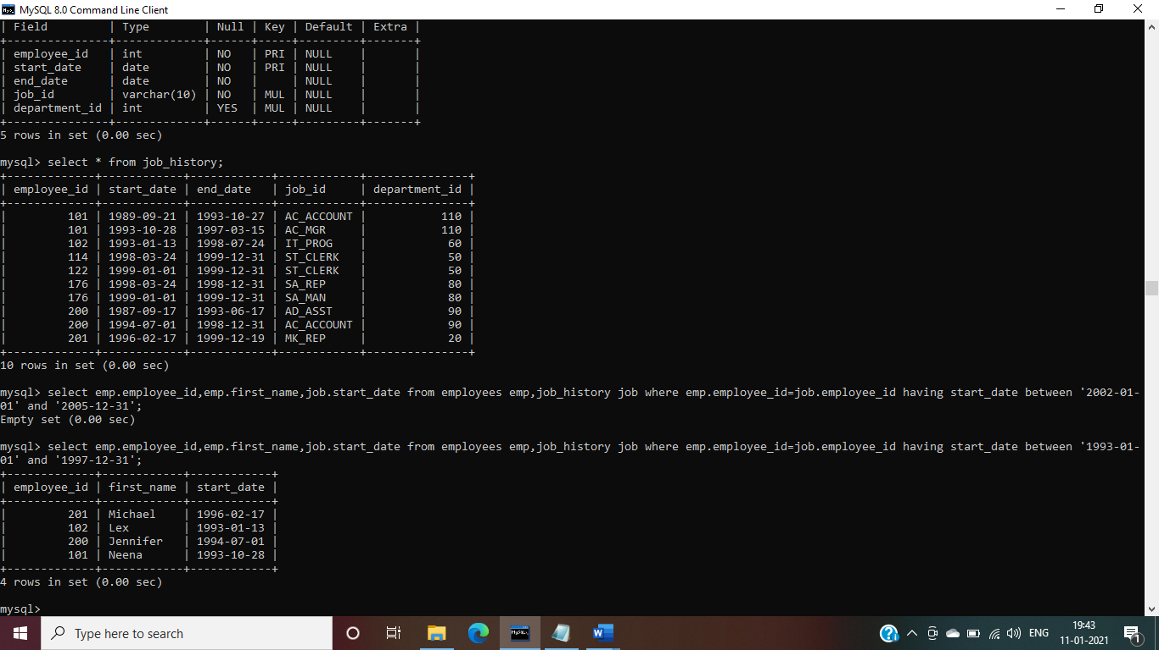

3) Display first name and join date of the employees who is either IT Programmer or Sales Man.

Ans- select first_name,hire_date from employees where job_id in ('IT_PROG','ST_MAN');

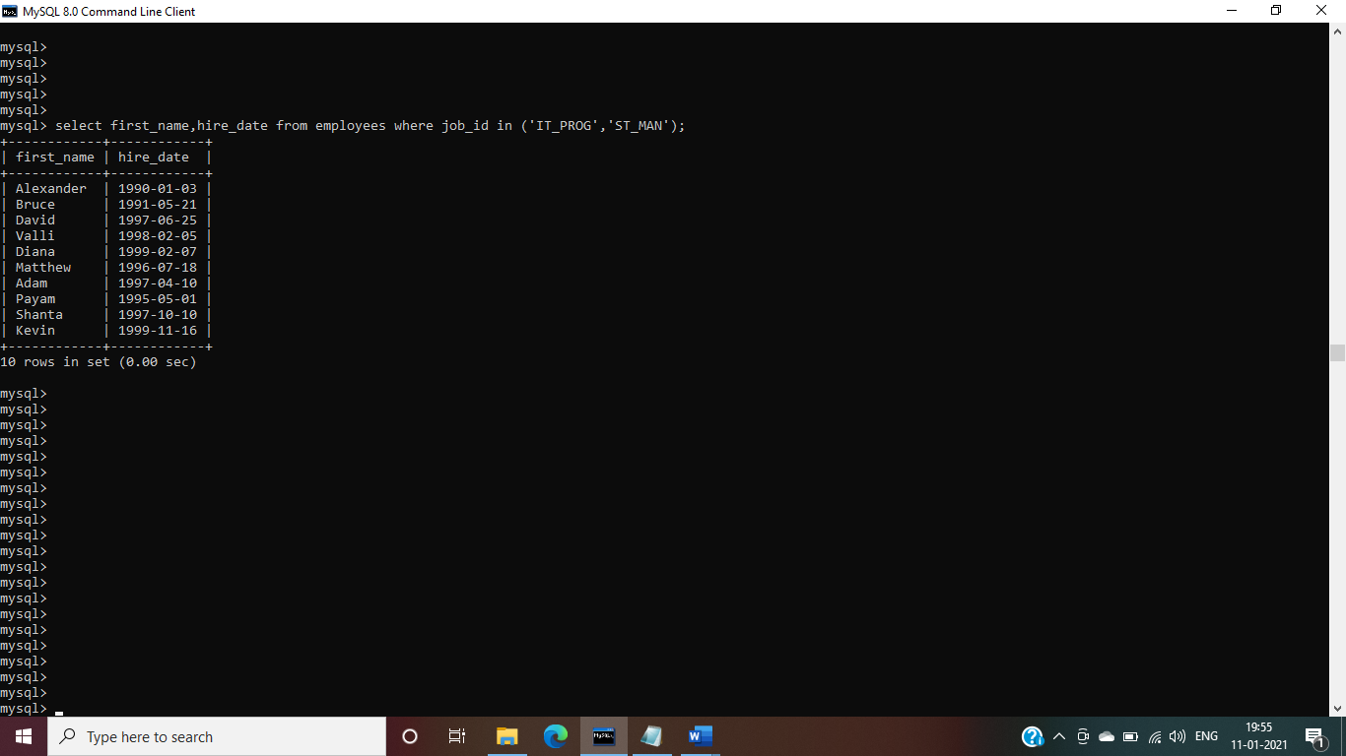

4) Display first name, salary, commission pct, and hire date for employees with salary less than 10000.

Ans- select first_name,salary,commission_pct,hire_date from employees where salary <10000;

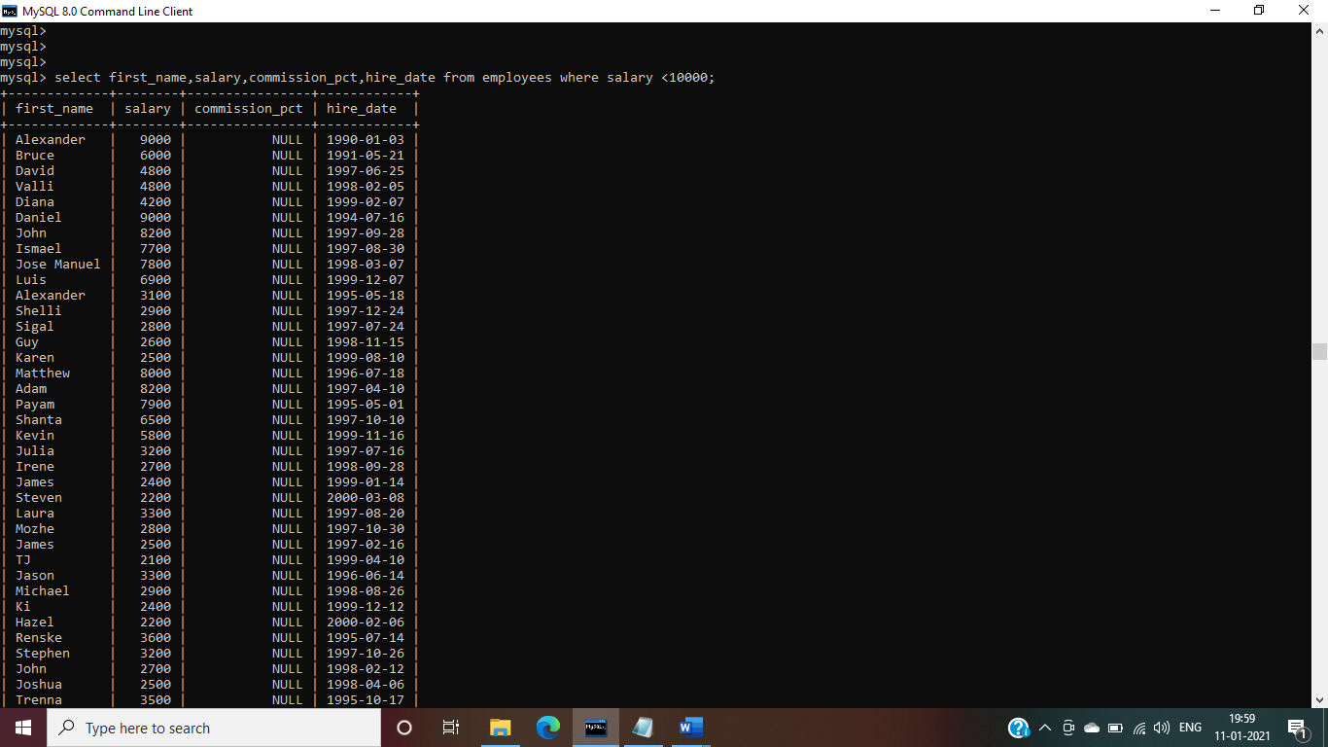

5) Display job Title, the difference between minimum and maximum salaries for jobs with max salary in the range 10000 to 20000.

Ans- select job_title,max_salary,min_salary,max_salary-min_salary as difference from jobs where max_salary> 10000 and max_salary< 20000;

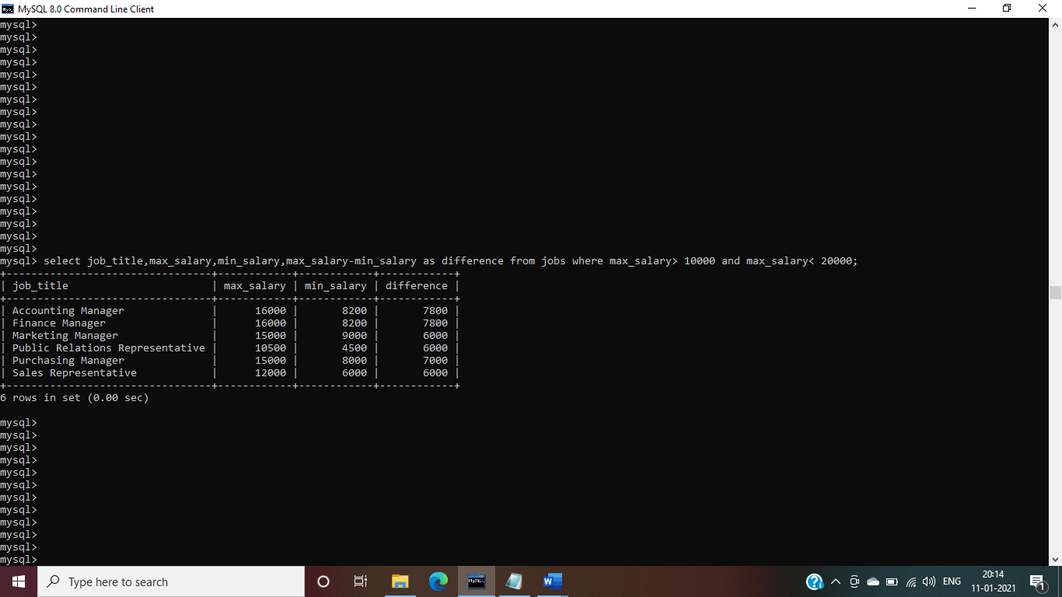

6) Display employees where the first name or last name starts with S.

Ans- select * from employees where first_name like 's%' and last_name like 's%';

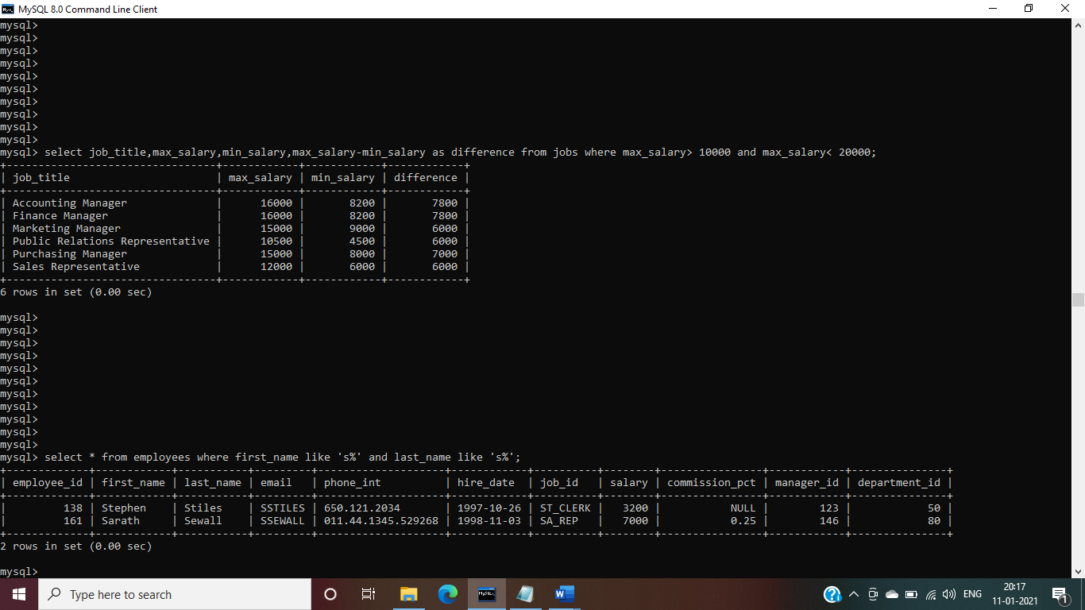

7) Display details of jobs in the descending order of the title.

Ans- select * from jobs order by job_title desc;

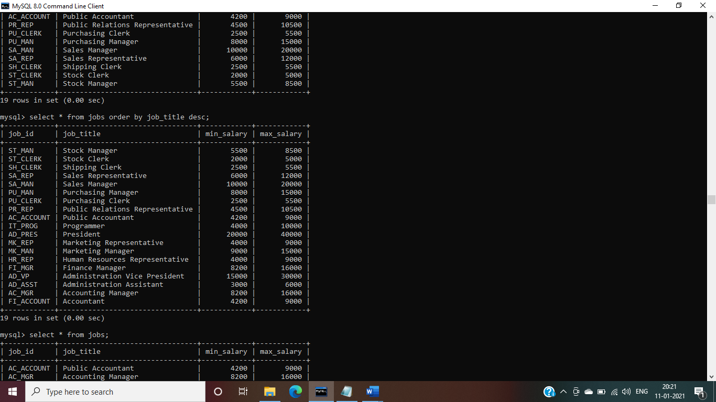

8) Display employees who joined in the month of May.

Ans- select * from employees where hire_date like '%05%';

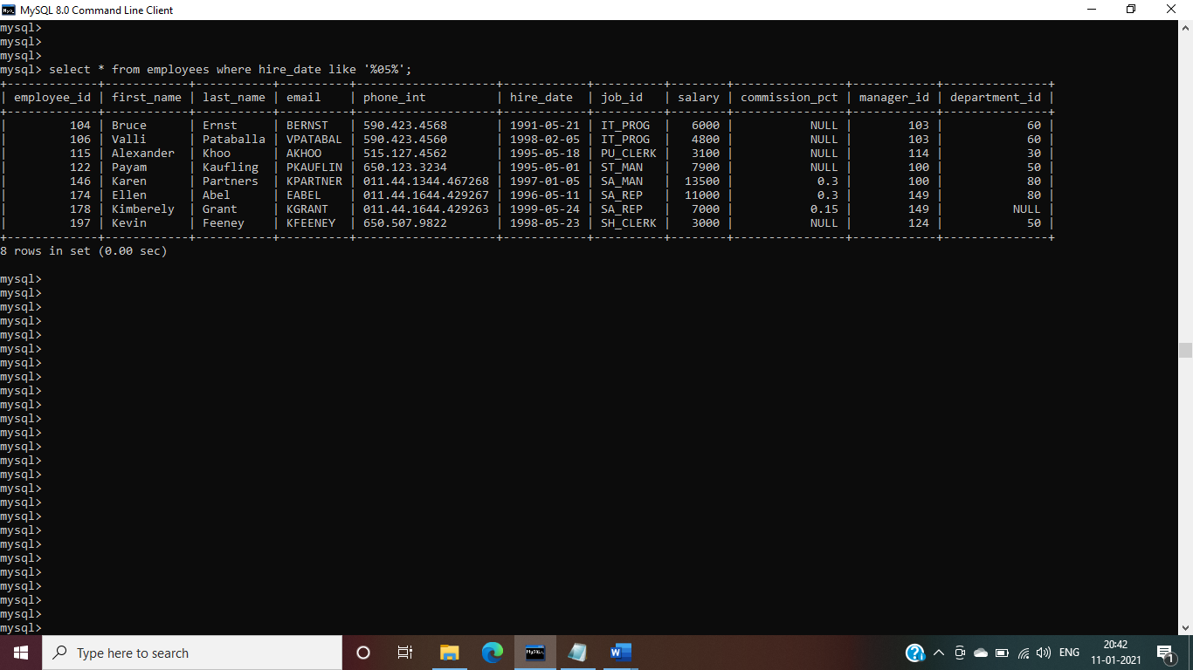

9) Display details of the employees where commission percentage is null and salary in the range 5000 to 10000 and department is 30.

Ans- select *from employees where commission_pct is null and salary >5000 and salary<10000 and department_id=30;

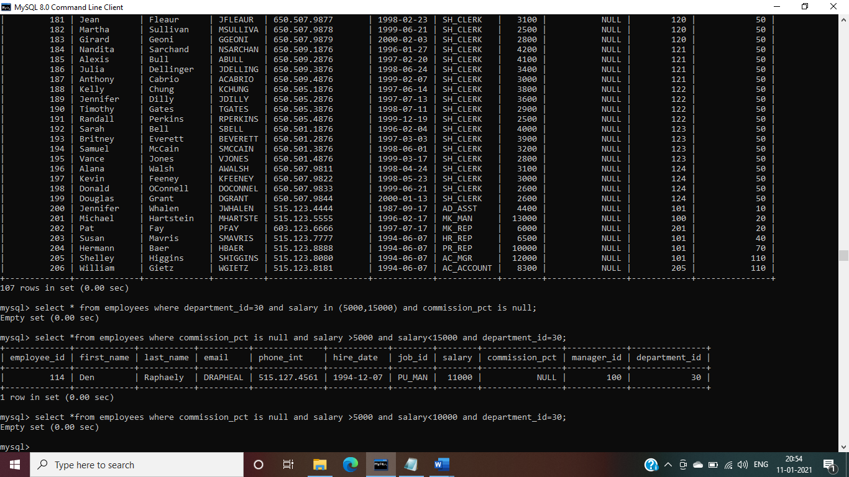

**Join**

1). Display job title, employee ID, number of days between ending date and starting date for all jobs in department 110 from job history.

Ans-select j.job_id,j.job_title,jh.employee_id,datediff(end_date,start_date) as number_of_days,jh.department_id from jobs j,job_history jh where j.job_id=jh.job_id having department_id=110;

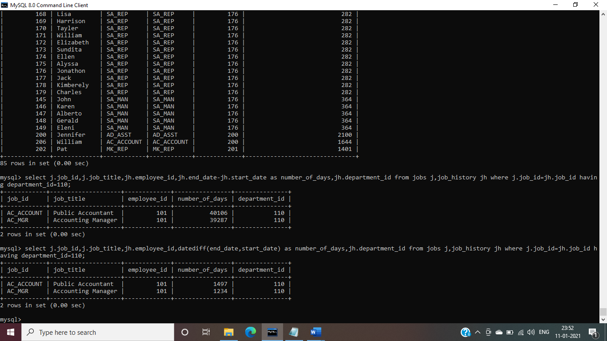

2) Display department name and manager first name.

Ans-select select d.department_name,e.first_name from departments d inner join employees e on d.manager_id=e.employee_id;

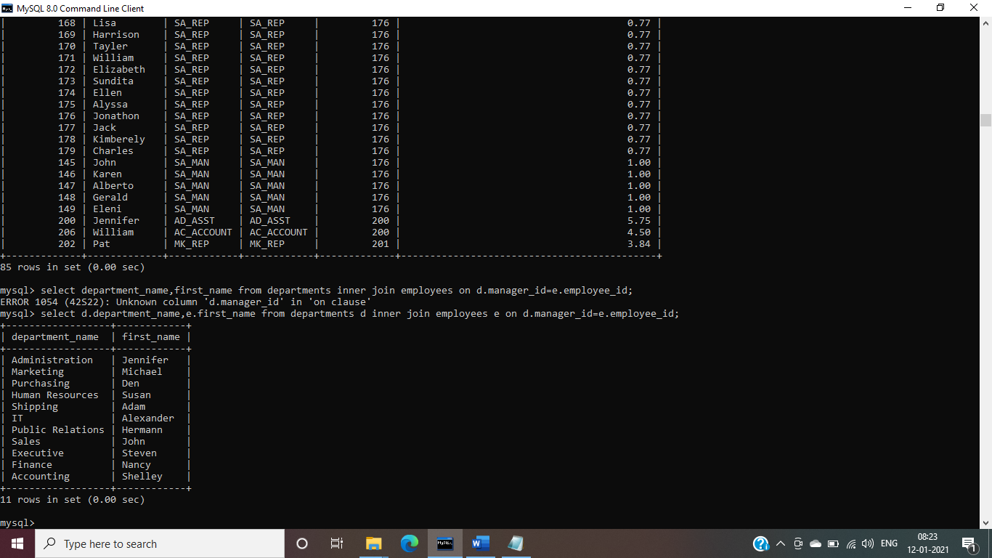

3) Display department name, manager name, and city.

Ans- select d.department_name,e.first_name,l.city from departments d ,employees e, locations l where d.manager_id=e.employee_id and d.location_id=l.location_id;

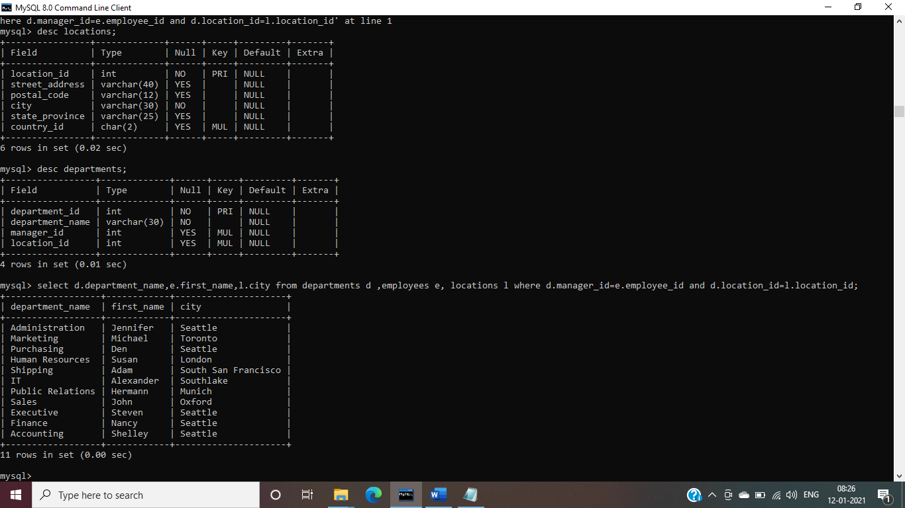

4) Display country name, city, and department name.

Ans- select dept.department_id,dept.department_name,dept.location_id,loc.location_id,loc.city,loc.country_id,c.country_id,c.country_name from departments dept,locations loc,countries c where loc.location_id=dept.location_id and c.country_id=loc.country_id;

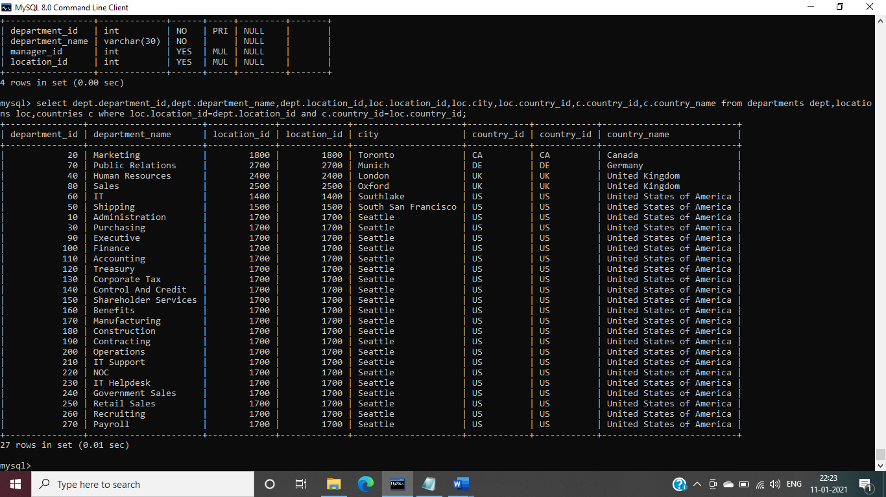

5) Display employee name and country in which he is working.

Ans- select emp.employee_id,emp.first_name,emp.department_id, dept.department_id,dept.location_id,loc.location_id,loc.country_id,c.country_id,c.country_name from employees emp,departments dept,locations loc,countries c where emp.department_id=dept.department_id and loc.location_id=dept.location_id and c.country_id=loc.country_id;

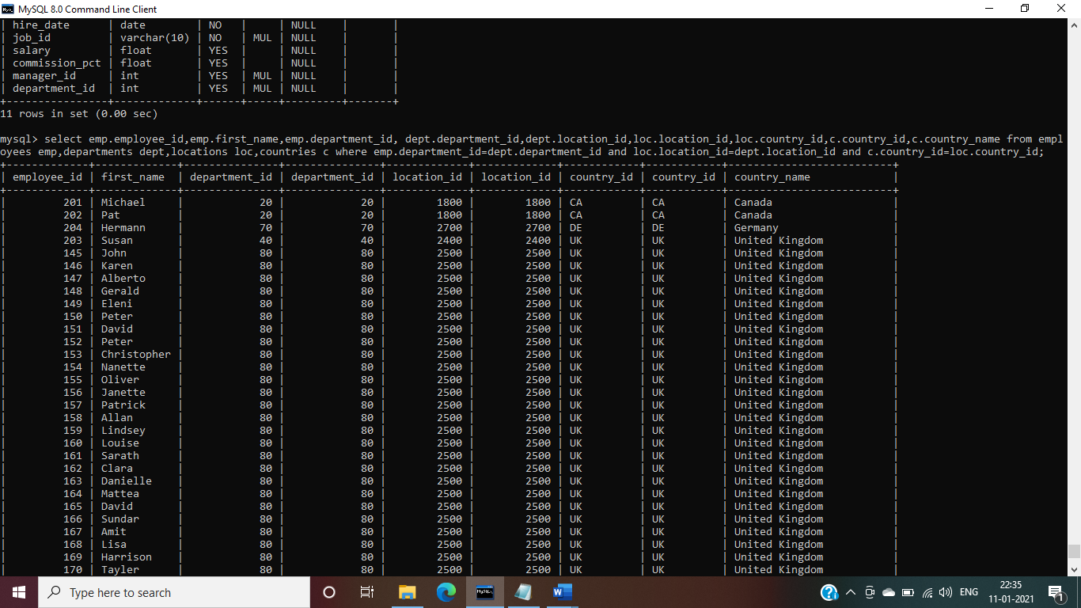

**Functions**

1. Display employees who joined in the month of May.

Ans- select * from employees where hire_date like '%05%';

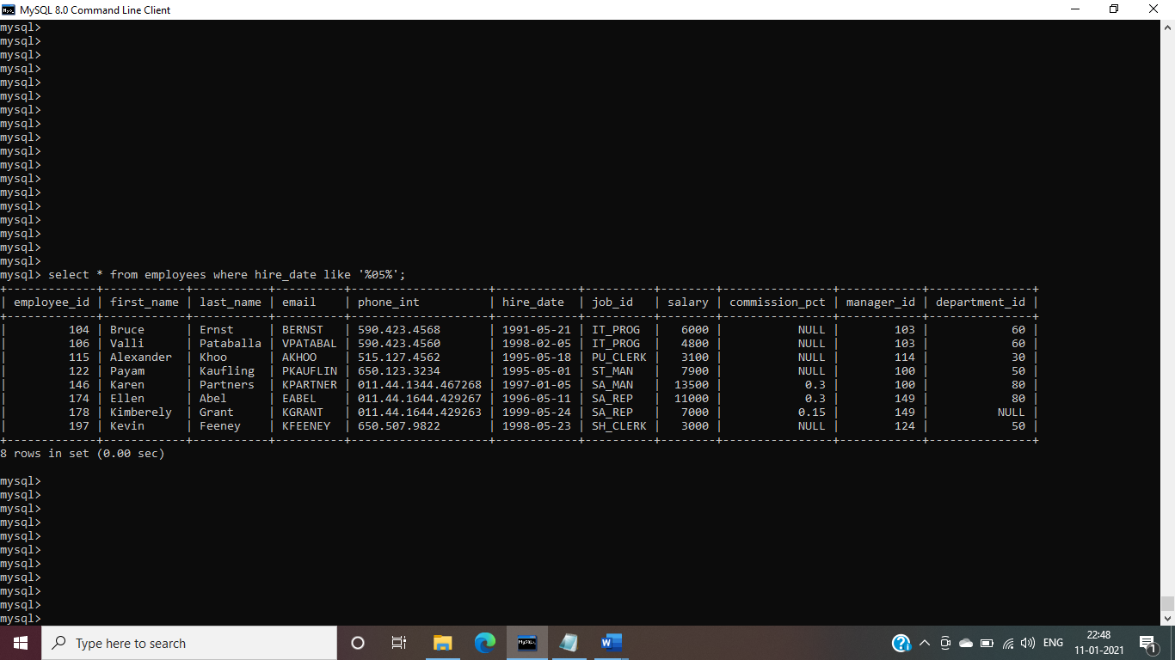

2. Display first name, salary, and round the salary to thousands.

Ans- select first_name,salary ,round(salary,-3) from employees;



3. Display first name and date of first salary of the employees.

Ans-select first_name,hire_date,last_day(hire_date)+('____-01-__') from employees;

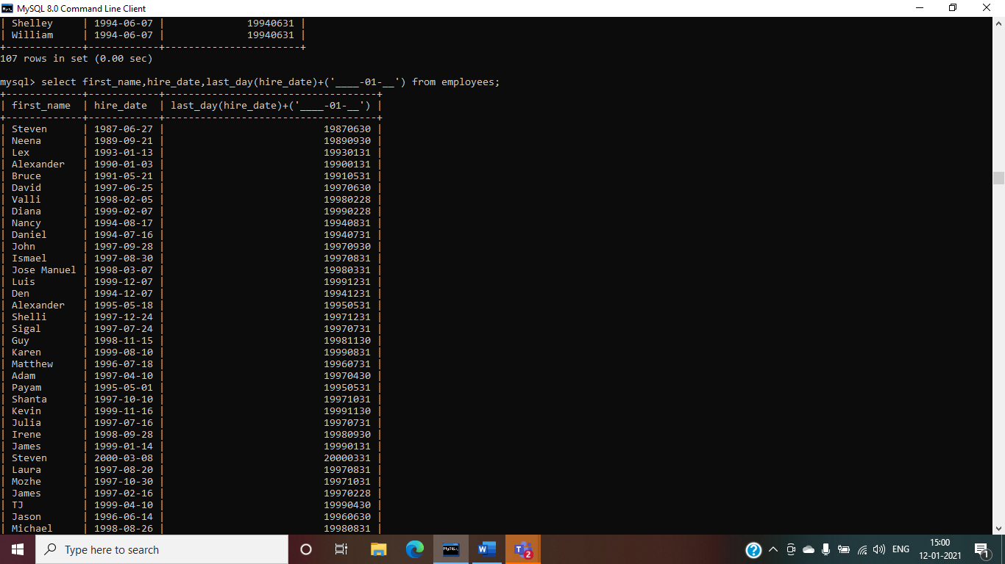

4. Display first name and experience of the employees.

Ans- select emp.employee_id,emp.first_name,emp.job_id,jh.job_id,jh.employee_id,datediff(end_date,start_date) from employees emp,job_history jh where emp.job_id=jh.job_id;

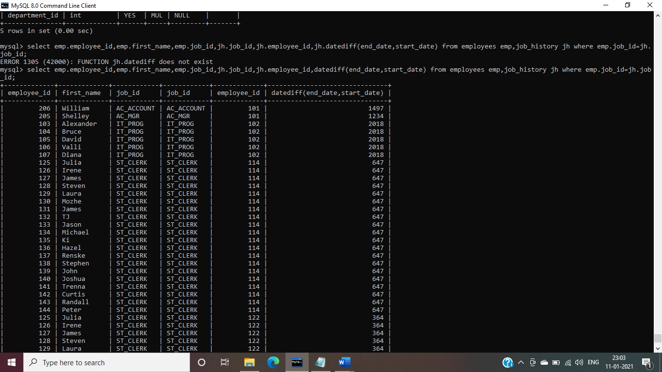

Or

select emp.employee_id,emp.first_name,emp.job_id,jh.job_id,jh.employee_id,round(datediff(end_date,start_date)/365,2) from employees emp,job_history jh where emp.job_id=jh.job_id;

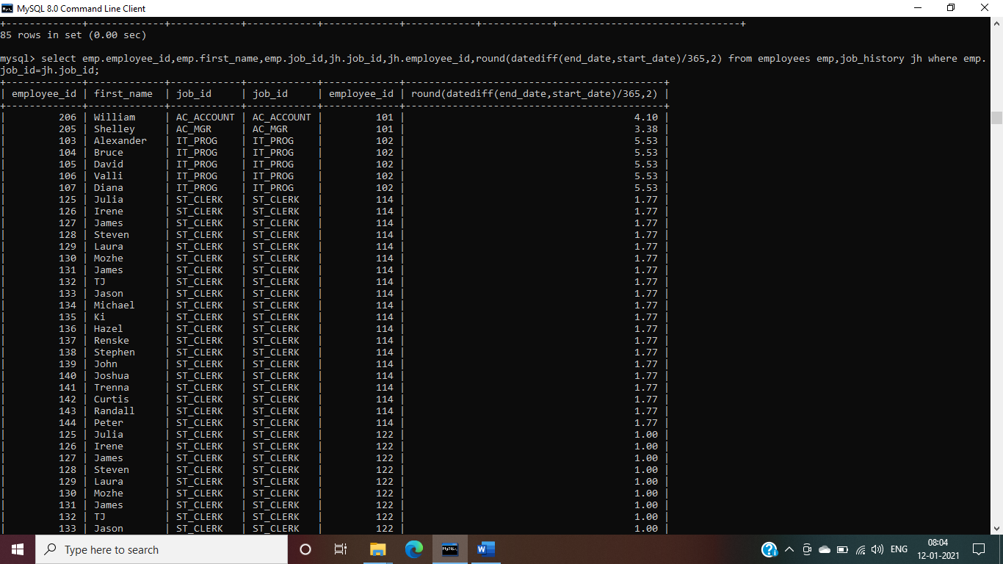

5. Display the length of first name for employees where last name contain character ‘b’ after 3rd position.

Ans- select first_name,length(first_name) from employees where first_name like '___b%';

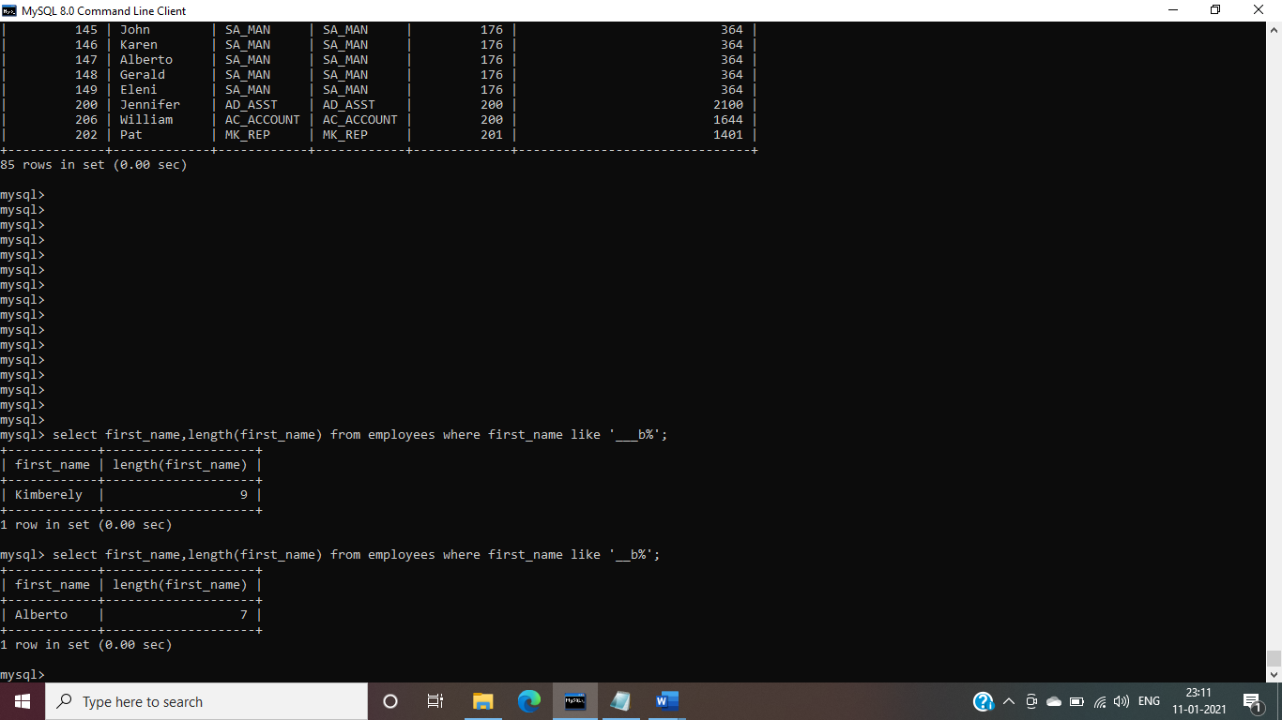

6. Display first name in upper case and email address in lower case for employees where the first name and email address are same irrespective of the case.

Ans-select upper (first_name),lower(email) from employees where upper(first_name)=upper(email);

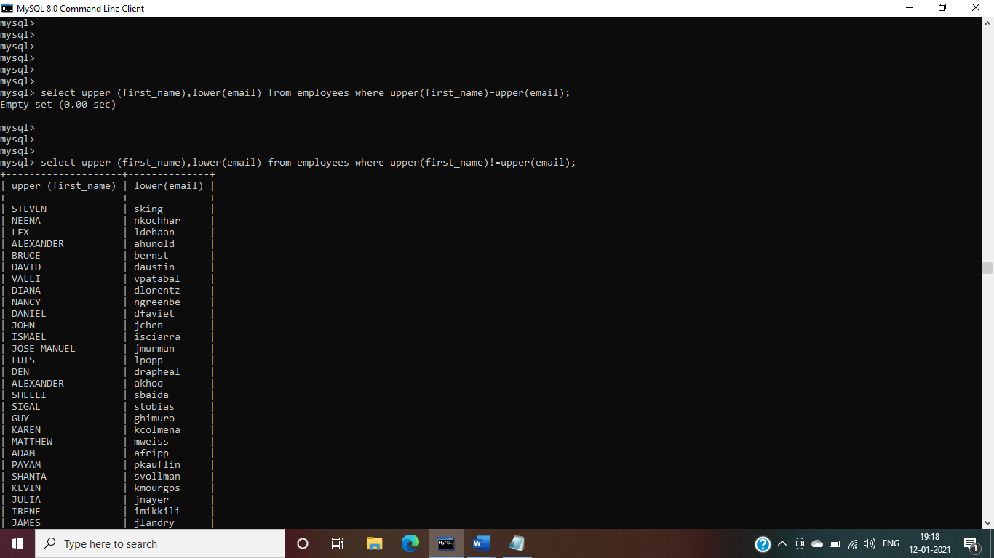

7. Display employees who joined in the current year.

Ans- select * from employees where year (hire_date)='1994';

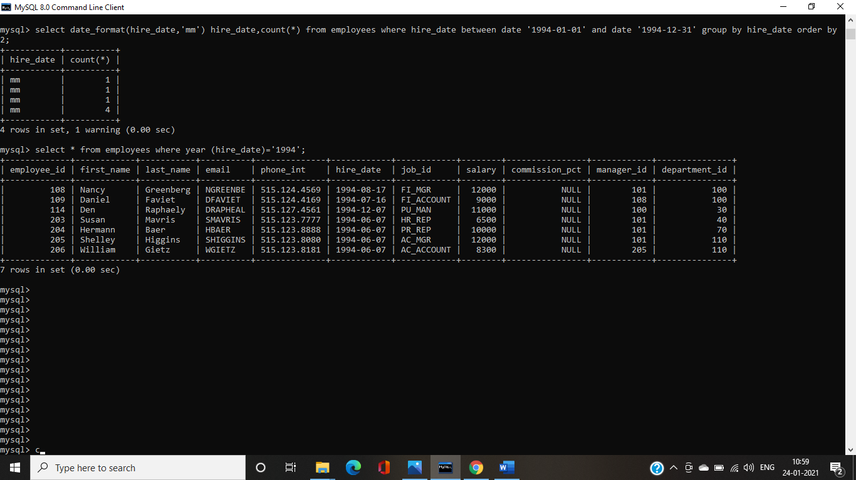

8. Display the number of days between system date and 1st January 1995.

Ans- select datediff(sysdate(),'1995-01-01');

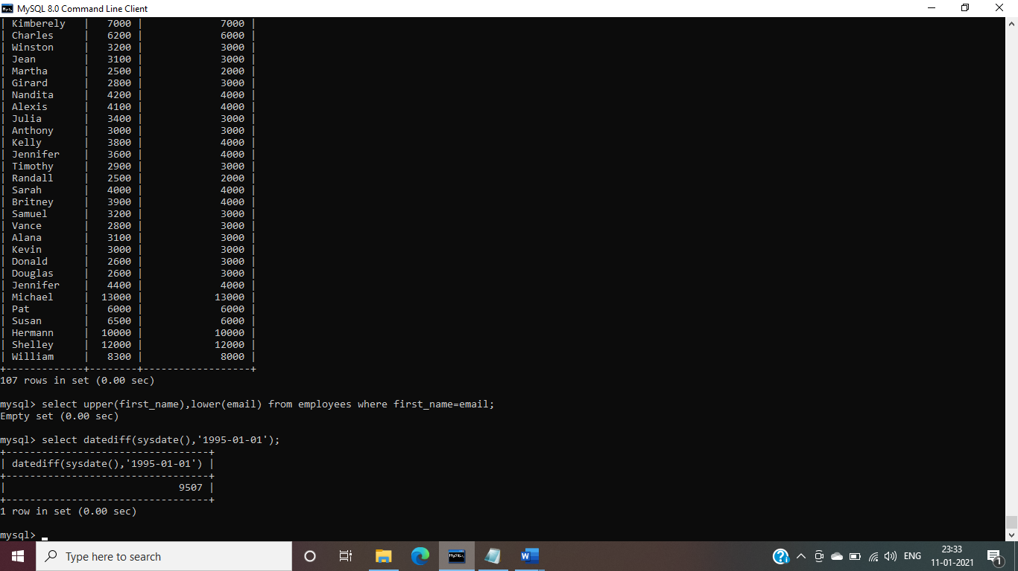

9. Display how many employees joined in each month of the current year.

Ans- select date_format(hire_date,'mm') hire_date,count(*) from employees where hire_date between date '1994-01-01' and date '1994-12-31' group by hire_date order by 2;

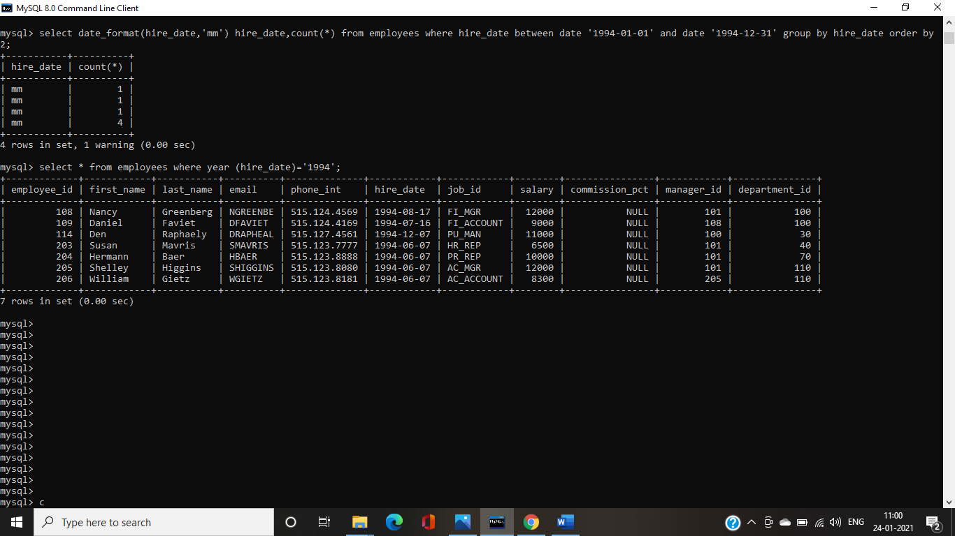

**MySQL Aggregate function**

1. Display employee ID and the date on which he ended his previous job.

Ans-select employee_id ,max(end_date) from job_history group by employee_id;

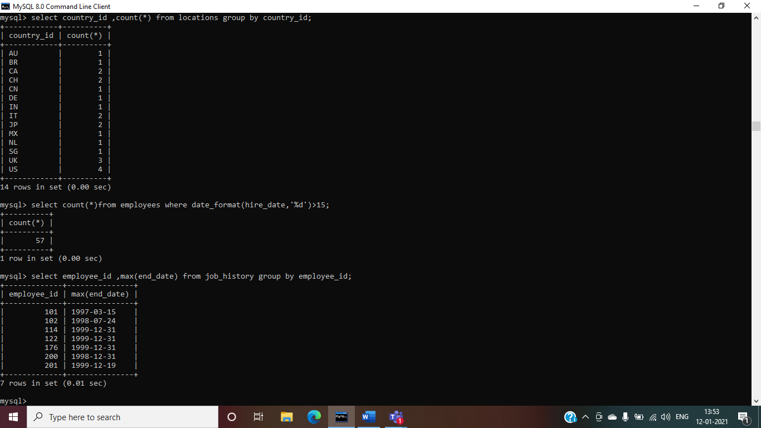

2. Display number of employees joined after 15th of the month.

Ans-select count(*)from employees where date_format(hire_date,'%d')>15;

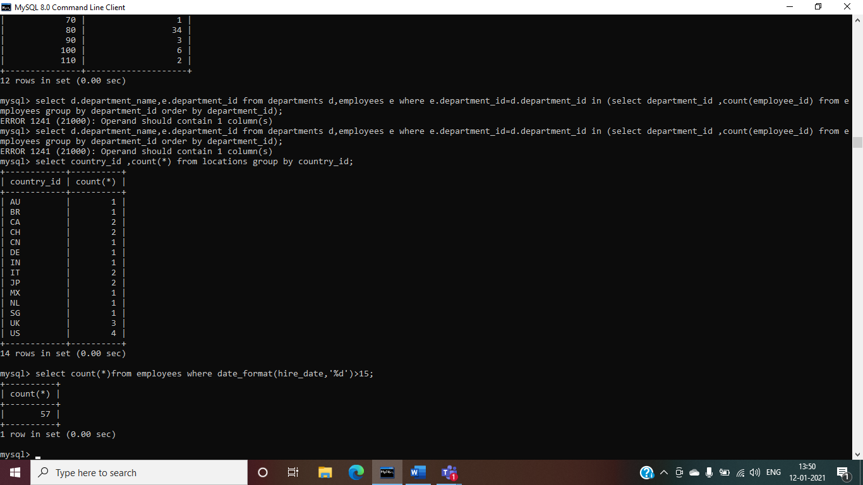

**select with Group by**

3. Display the country ID and number of cities we have in the country.

Ans-select country_id ,count(*) from locations group by country_id;

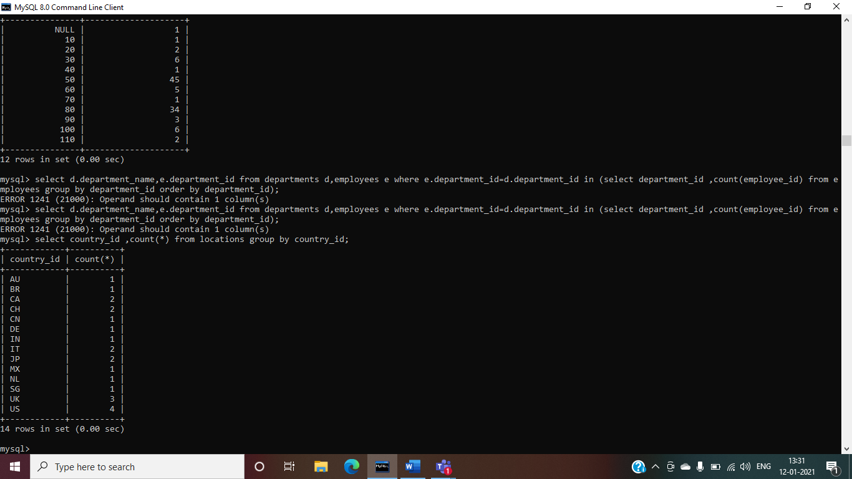

4. Display average salary of employees in each department who have commission percentage.

Ans-select department_id ,avg(salary) from employees where commission_pct is not null group by department_id;

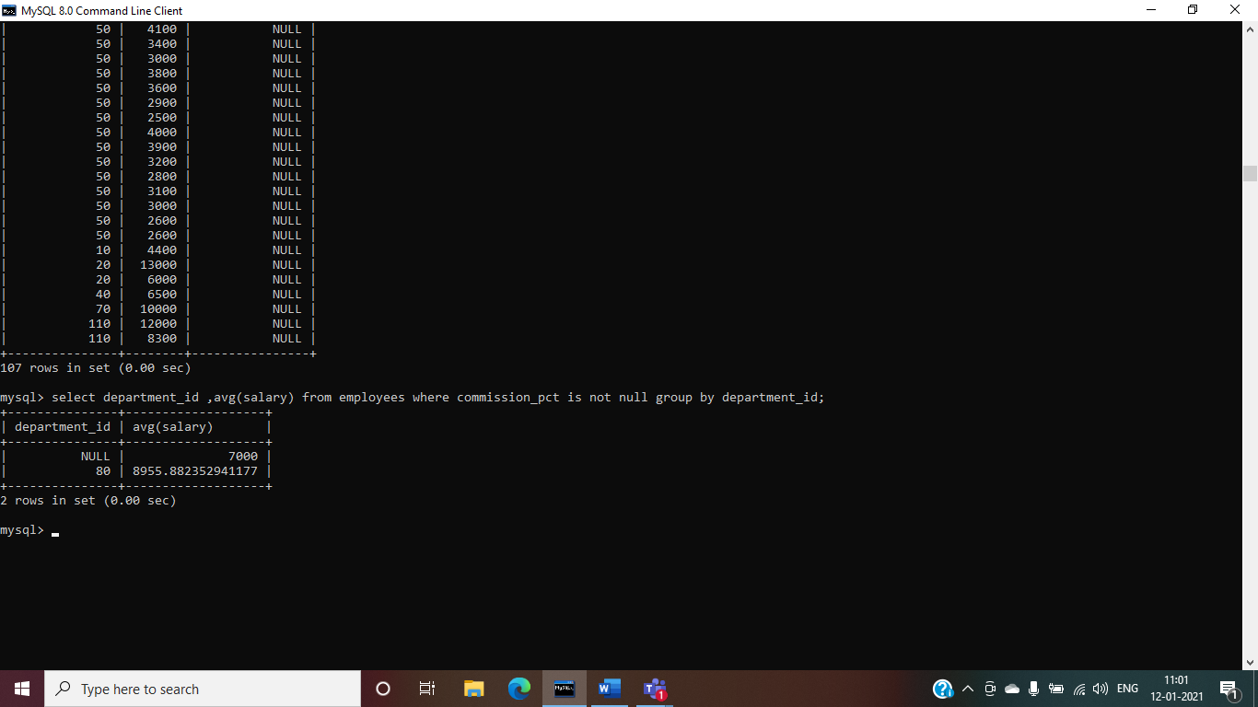

5. Display job ID, number of employees, sum of salary, and difference between highest salary and lowest salary of the employees of the job.

Ans-select job_id,count(*),sum(salary),max(salary)-min(salary) as salary from employees group by job_id;

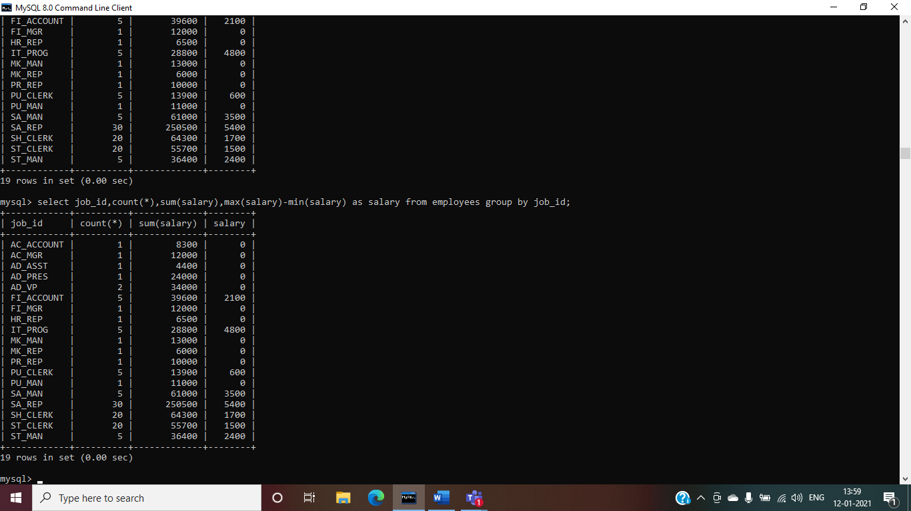

6. Display job ID for jobs with average salary more than 10000.

Ans-select job_id , avg(salary) from employees group by job_id having avg(salary)>10000;

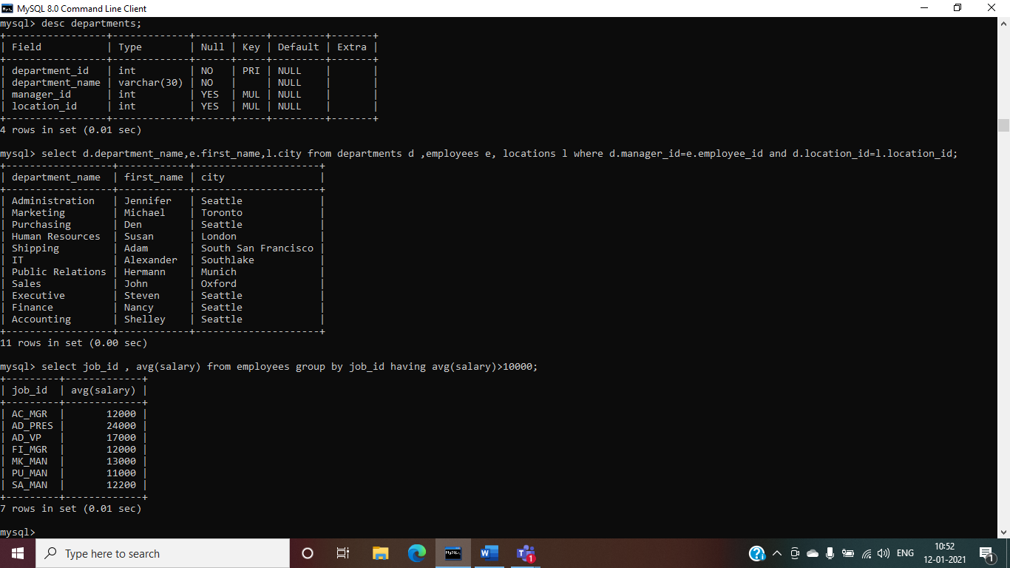

7. Display years in which more than 10 employees joined.

Ans-select date_format(hire_date,'%y') from employees group by date_format(hire_date,'%y') having count(employee_id)>1;

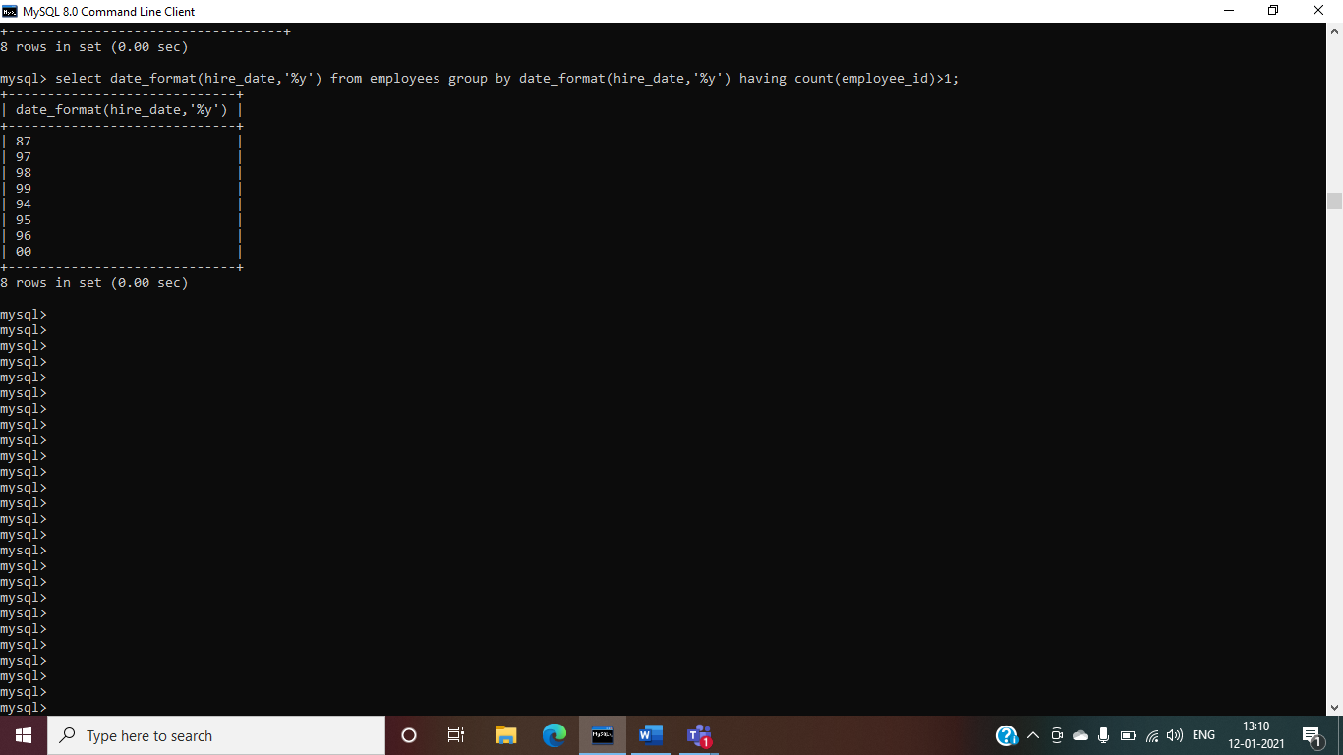

8. Display departments in which more than five employees have commission percentage.

Ans-select department_id from employees where commission_pct is not null group by department_id having count(commission_pct)>5;

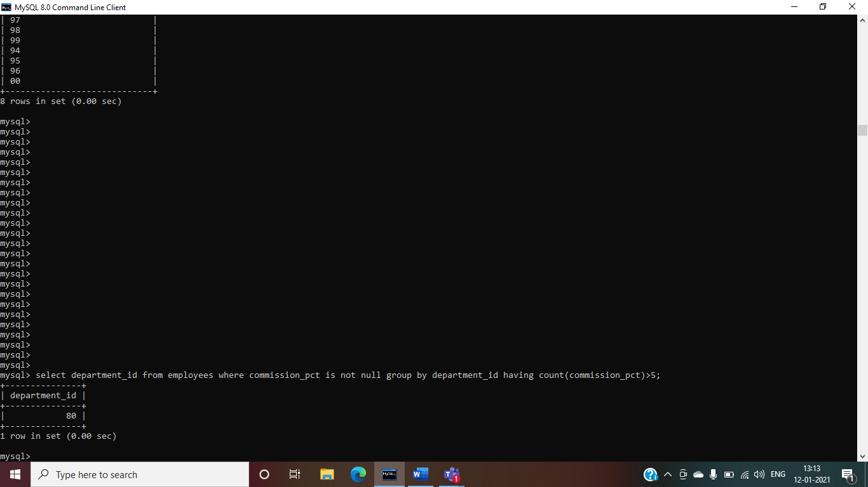

9. Display department name and number of employees in the department.

Ans-select department_name,count(*) from employees natural join departments group by department_name;

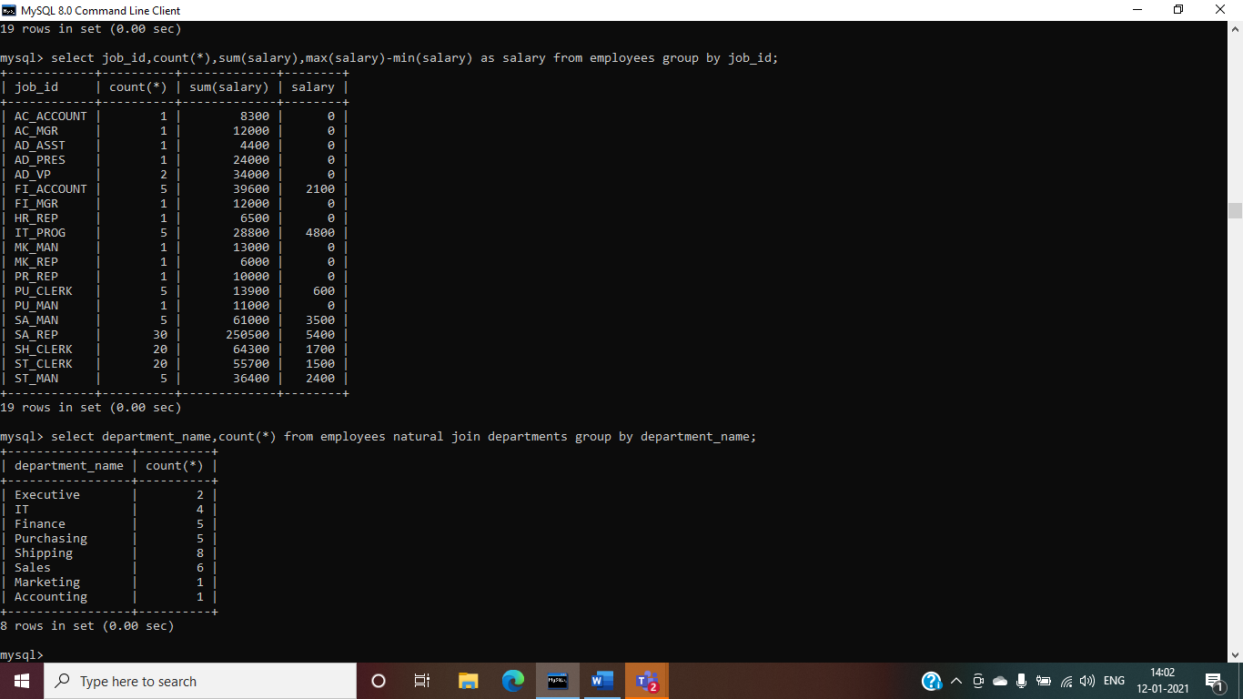

10. Display employee ID for employees who did more than one job in the past.

Ans-select employee_id from job_history group by employee_id having count(*)>1;

